Section I: Scenario Demographics

Scenario Title: | Dysrhythmia secondary to hyperkalemia
Date of Development: | 06/04/2015 (DD/MM/YYYY)
Target Learning Group: | Juniors (PGY 1 – 2) Seniors (PGY ≥ 3) All Groups

Section II: Scenario Developers

Scenario Developer(s): | Kyla Caners
Affiliations/Institution(s): | McMaster University
Contact E-mail (optional): | kcaners@gmail.com

Section III: Curriculum Integration

Learning Goals & Objectives
Educational Goal: | To expose learners to a situation where the diagnosis of hyperkalemia on ECG is critical.
CRM Objectives: | Lead team effectively through a case that requires administration of multiple medications.
Medical Objectives: | - Recognize hyperkalemia as possible cause of ST elevation and treat accordingly.  - Appropriately manage hyperkalemia with calcium, insulin and glucose, bicarbonate, ventolin, and a call for hemodialysis.  - Recognize sine wave as indicative of hyperkalemia and alter ACLS accordingly to include administration of calcium and bicarbonate.

Case Summary: Brief Summary of Case Progression and Major Events
A 52 year-old male with end-stage renal disease (requiring dialysis) is brought in by EMS feeling weak and dizzy. He missed dialysis for the first time over the weekend to attend his niece’s wedding. On presentation, his heart rate is 50 and his ECG demonstrates a wide complex rhythm with peaked T waves that EMS interprets as a STEMI. If the team recognizes the possibility of hyperkalemia and treats it appropriately, the patient’s QRS will narrow. If the hyperkalemia is not recognized, the patient will arrest.

References
Pfennig CL, Slovis CM. (2013). Electrolyte disorders. In J. Marx, R. Hockberger & R. Walls (Eds.), Rosen's emergeny medicine - concepts and clinical practice. pp. (1636-51). Philadelphia, PA.:Saunders.
Website: accessed on April 14, 2015: http://lifeinthefastlane.com/ecg-library/basics/hyperkalaemia/

Section IV: Scenario Script

A. Scenario Cast & Realism
Patient: | Computerized Mannequin |  |  |  |  | Realism:  Select most important dimension(s) |  |  | Conceptual
 | Mannequin |  |  |  |  |  |  |  | Physical
 | Standardized Patient |  |  |  |  |  |  |  | Emotional/Experiential
 | Hybrid |  |  |  |  |  |  |  | Other:
 | Task Trainer |  |  |  |  |  |  |  | N/A
Confederates | Brief Description of Role
None.
B. Required Monitors
EKG Leads/Wires |  |  | Temperature Probe |  |  |  | Central Venous Line
NIBP Cuff |  |  | Defibrillator Pads |  |  |  | Capnography
Pulse Oximeter |  |  | Arterial Line |  |  |  | Other:
C. Required Equipment
Gloves |  |  | Nasal Prongs |  |  |  | Scalpel
Stethoscope |  |  | Venturi Mask |  |  |  | Tube Thoracostomy Kit
Defibrillator |  |  | Non-Rebreather Mask |  |  |  | Cricothyroidotomy Kit
IV Bags/Lines |  |  | Bag Valve Mask |  |  |  | Thoracotomy Kit
IV Push Medications |  |  | Laryngoscope |  |  |  | Central Line Kit
PO Tabs |  |  | Video Assisted Laryngoscope |  |  |  | Arterial Line Kit
Blood Products |  |  | ET Tubes |  |  |  | Other:
Intraosseous Set-up |  |  | LMA |  |  |  | Other:
D. Moulage
None required.

E. Approximate Timing
Set-Up: |  | 3 min |  | Scenario: | 12 min |  |  | Debriefing: |  | 15 min

Section V: Patient Data and Baseline State

A. Clinical Vignette: To Read Aloud at Beginning of Case
Geoff is a 52 year old male who is brought to the ED by EMS as a STEMI activation. He is not having chest pain, but has been feeling weak and dizzy today. He is diabetic and hypertensive and was started on hemodialysis 3 months ago for ESRD. He missed dialysis on the weekend for the first time so that he could attend his niece’s wedding.
B. Patient Profile and History
Patient Name: Geoff Normandy |  |  |  |  |  | Age: 52 |  |  |  |  |  |  |  | Weight: 80kg
Gender: M F |  |  |  |  |  | Code Status: Full
Chief Complaint: Weak and dizzy
History of Presenting Illness: Felt unwell since waking up this morning. Feels light headed with standing and like he “has no energy.” Nauseous. Missed dialysis on the weekend to attend his niece’s wedding.
Past Medical History: |  | DM2 |  |  |  |  | Medications: |  |  |  |  | Ramipril 5mg OD
 |  | HTN |  |  |  |  |  |  |  |  |  | Levothyroxine 100mcg OD
 |  | Hypothyroid |  |  |  |  |  |  |  |  |  | Insulin
 |  | Dyslipidemia |  |  |  |  |  |  |  |  |  | Crestor 20mg OD
Allergies: Penicillin
Social History: Worked as a banker, but is now unemployed. No EtOH/smoking/ilicit drug use.
Family History: No hx CAD. All have diabetes.
Review of Systems: |  | CNS: |  |  | Feels lightheaded, dizzy.
 |  | HEENT: |  |  | Nil.
 |  | CVS: |  |  | No CP. No palps.
 |  | RESP: |  |  | No SOB.
 |  | GI: |  |  | Nausea.
 |  | GU: |  |  | Anuric.
 |  | MSK: |  |  | Nil. |  |  |  |  |  |  |  | INT: |  | Nil.
C. Baseline Simulator State and Physical Exam
No Monitor Display |  |  |  | Monitor On, no data displayed |  |  |  |  |  |  | Monitor on Standard Display
HR: 50/min |  |  | BP: 92/65 |  |  |  |  | RR: 16/min |  |  |  |  |  |  | O₂SAT: 97% RA
Rhythm: Idioventricular |  |  | T: 36.4ºC |  |  |  |  | Glucose: 12.7 mmol/L |  |  |  |  |  |  | GCS: 13 (E3 V4 M6)
General Status: Slightly diaphoretic. Looks unwell.
CNS: | A+Ox3. No focal neurologic deficits. No asterixis.
HEENT: | PERLA. 3mm.
CVS: | Normal S1/S2. No murmur.
RESP: | GAEB. No adventitious sounds.
ABDO: | Soft, NT.
GU: | Nil.
MSK: | Nil. |  |  |  |  |  |  |  | SKIN: | No rashes.

Scenario States, Modifiers and Triggers
Patient State | Patient Status | Learner Actions, Modifiers & Triggers to Move to Next State
1. Baseline State  Rhythm: idioventricular  HR: 50/min  BP: 92/65  RR: 20/min  O₂SAT: 97% RA  T: 36.4ºC | Diaphoretic, awake, answering questions. Feels dizzy. | Learner Actions  - IV, O2, monitors  - ECG  - Blood work including trop  - Fluid bolus  - Check cap sugar (12.7)  - Administer calcium gluconate 1g (10-30ml) iv  - ± ASA 160mg PO chew | Modifiers  Changes to patient condition based on learner action  - Calcium given HR 70, QRS narrows (change to sinus)  - Fluid bolus BP 102/67  Triggers  For progression to next state  - Calcium not given by 3 min 2. Arrest  - Initial work-up complete and calcium given 4. Blood work back
2. Arrest  Rhythm Asystole  BP -/-  RR 0  O₂SAT ? | Unresponsive with no vitals. | Learner Actions  - Quality CPR  - Calcium chloride 1-2 amps  - NaHCO3 amps  - Epinephrine amps  - 1 amp D50 then insulin R 10 units iv | Modifiers  - 7 minutes into case critical VBG back showing hyperkalemia  Triggers  - 2 amps calcium given or 10 minutes into case 3. NSR
3. NSR  Rhythm sinus  HR 70  BP 105/70  RR 16  O₂SAT 97% RA | Awake and responding. | Learner Actions  - Ventolin 20mg nebulized or 24 puffs  - 1amp D50 then insulin R 10 units iv (if not yet done)  - Repeat ECG  - ± HCO3 amp  - Call nephro re: dialysis | Modifiers  - Ventolin given HR 90  Triggers  - Two treatments for hyperK given and Nephro called End Case  - 12 minutes End Case
4. Blood work Back  Rhythm sinus  HR 70  BP 105/70 | Awake, alert, no longer feels dizzy. | Learner Actions  - Ventolin 20mg nebulized or 24 puffs  - 1amp D50 then insulin R 10 units iv  - Repeat ECG  - ± HCO3 amp  - ± Lasix 40mg iv (if still makes urine)  - Call nephro re: dialysis | Modifiers  - Given critical VBG result showing hyperkalemia as state starts  - Ventolin given HR 90  Triggers  - Two treatments for hyperK given and Nephro called End Case  -12 minutes End Case
Section VI: Scenario Progression

Section VII: Supporting Documents, Laboratory Results, & Multimedia

Laboratory Results
Critical VBG:
pH 7.27
PCO2 35
PO2 45
HCO3 20
Lactate 2.5
Na 142
K 8.6
Cl 105

Images (ECGs, CXRs, etc.)
ECG 1: Hyperkalemia STEMI mimic  (Source: http://lifeinthefastlane.com/ecg-library/basics/hyperkalaemia/) | 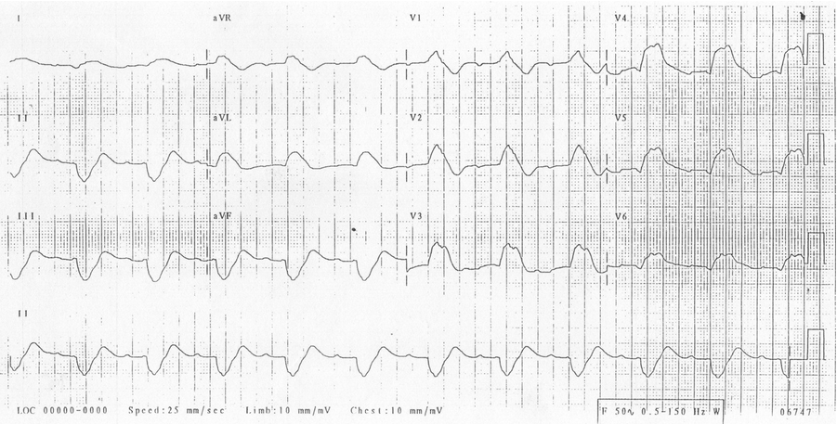
ECG 2: NSR with no ST changes  (Source: http://cdn.lifeinthefastlane.com/wp-content/uploads/2011/12/normal-sinus-rhythm.jpg) | 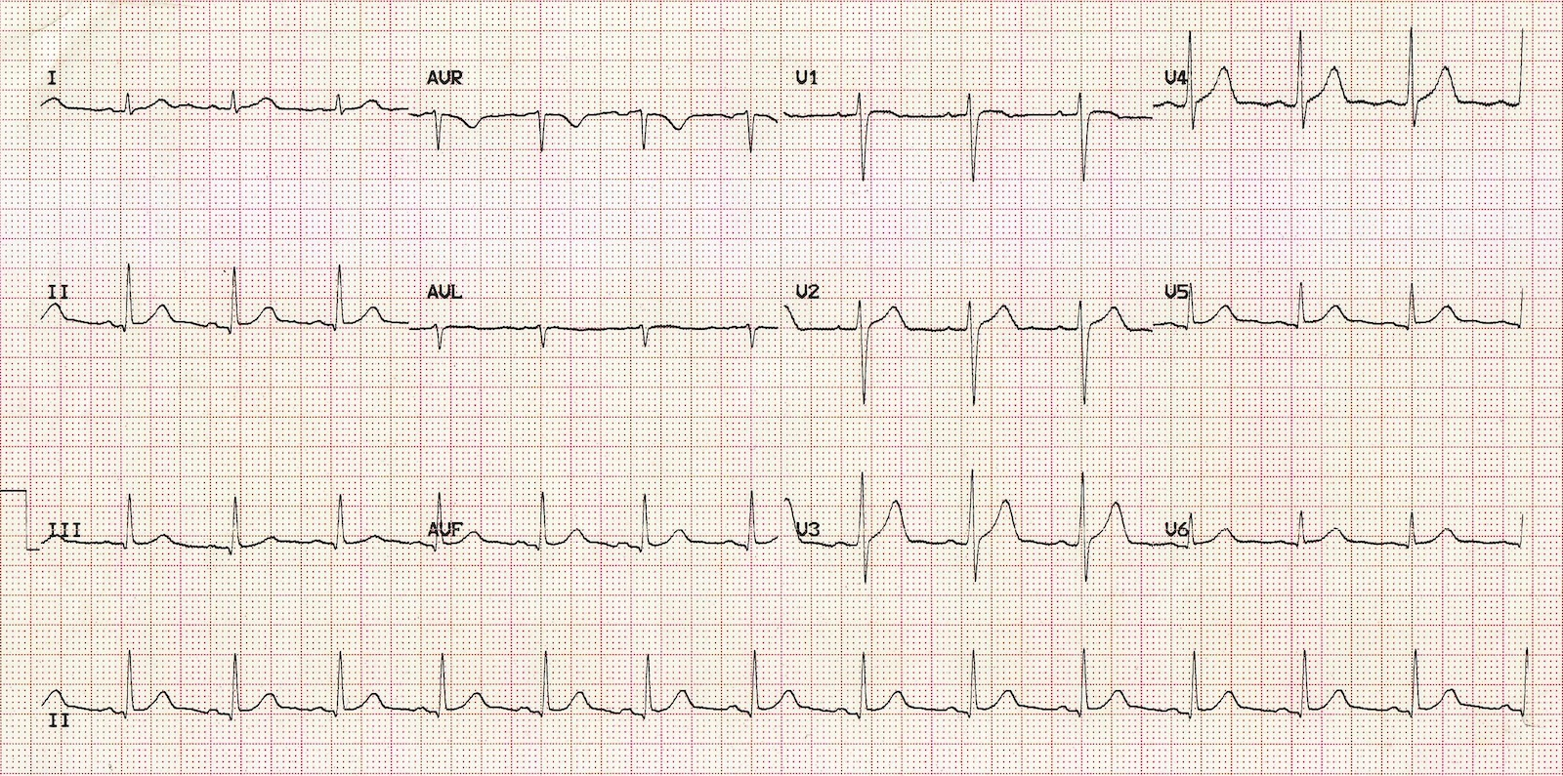

Section VIII: Debriefing Guide

General Debriefing Plan
Individual | Group |  | With Video | Without Video
Objectives
Educational Goal: |  | To expose learners to a situation where the diagnosis of hyperkalemia on ECG is critical.
CRM Objectives: |  | Lead team effectively through a case that requires administration of multiple medications.
Medical Objectives: |  | - Recognize hyperkalemia as possible cause of ST elevation and treat accordingly.  - Appropriately manage hyperkalemia with calcium, insulin, ventolin, and a call for hemodialysis.  - Recognize sine wave as indicative of hyperkalemia and alter ACLS accordingly to include administration of calcium and bicarbonate.
Sample Questions for Debriefing
- What are the ECG changes associated with hyperkalemia?
- What are some mimics of ST elevation on an ECG?
- List 7 treatments for hyperkalemia with specific doses.
Key Moments
Identification of hyperkalemia on ECG.
Alteration of ACLS management to include copious calcium and HCO3 in context of hyperkalemia
Recognition of need to offer multiple treatments for hyperkalemia and of need to call nephro for dialysis.

